

PROJECT TITLE – MINI BANKING SIMULATION SYTEM
SUBMITTED BY – ANANYA SINGH
REGISTRATION NUMBER – 25BSA10065
PROGRAMME – B.TECH
COURSE CODE – CSE1021
COURSE NAME – CSE(CLOUD COMPUTING AND AUTOMATION)
FACULTY – MOSIS DIAN
INSTITUTION – VELLORE INSTITUTE OF TECHNOLOGY BHOPAL
YEAR – 2025 – 29

INTRODUCTION
The Mini Banking Simulation System is a simple console-based application that demonstrates basic banking operations such as creating accounts, depositing money, withdrawing funds, transferring amounts, and viewing transaction history. It is designed to help beginners understand core programming concepts like functions, file handling, classes, modular code, and user interaction through a command-line interface.
The project stores account data using JSON files, ensuring that information is saved even after the program closes. By simulating real banking logic in a simplified way, this system provides a practical learning experience for first-year students and serves as a foundation for building more advanced financial applications in the future.

PROBLEM STATEMENT
The aim of this project is to create a simple console-based system that simulates basic banking operations. Users should be able to create accounts, deposit and withdraw money, transfer funds, and view their transaction history. The system must store account information safely, prevent invalid operations, and keep data available even after the program is closed. This project provides a beginner-friendly model of how real banking processes work through programming.

OBJECTIVES
- To design a simple console-based system that performs basic banking operations.
- To allow users to create accounts, deposit money, withdraw funds, transfer amounts, and view balances.
- To maintain a transaction history for every account in an organized manner.
- To implement data storage using files so that account information is saved even after the program ends.
- To help beginners understand core programming concepts such as modular coding, file handling, classes, and user input validation.
- To simulate real-world banking logic in a simplified, easy-to-understand form.

FUNCTIONAL REQUIREMENTS
1.Account Creation
- The system must allow users to create a new bank account by entering basic details such as name and initial deposit.
2. Deposit Money
- Users should be able to deposit a valid amount into any existing account.
3. Withdraw Money
- The system must allow withdrawals while ensuring the balance is sufficient to complete the transaction.
4.Transfer Funds
- Users should be able to transfer money from one account to another securely.
5. View Account Balance
- The system must display the current balance of a selected account.
NON-FUNCTIONAL REQUIREMENTS
1.Usability
The system should have a simple and easy-to-understand command-line interface.

2. Reliability
The system must perform operations accurately without data corruption.It should prevent invalid operations like overdrawing an account.

3. Performance
All operations (deposit, withdraw, search, transfer) should execute quickly with minimal delay. File loading and saving must complete efficiently.

4. Data Integrity
Account and transaction data must always remain consistent.
Partial transactions must not be saved in case of errors.

5. Security
The system should handle user inputs safely and prevent improper operations.
Sensitive actions like withdrawal and transfer must have proper checks.

SYSTEM ARCHITECTURE
1. User Interface Layer (CLI)
- Files: main.py, cli.py
- Handles user input and displays output.
- Shows menus and takes commands from the user.
2. Business Logic Layer
- File: bank.py
- Contains the main banking operations (create account, deposit, withdraw, transfer).
- Ensures rules and validations are followed.
3. Data Layer
- Files: models.py, storage.py, data/bank_data.json
- Defines data structures (Account, Transaction).
- Stores and retrieves data using JSON files for persistence.
4. Utility Layer
- File: utils.py
- Provides helper functions (input validation, formatting, etc.).
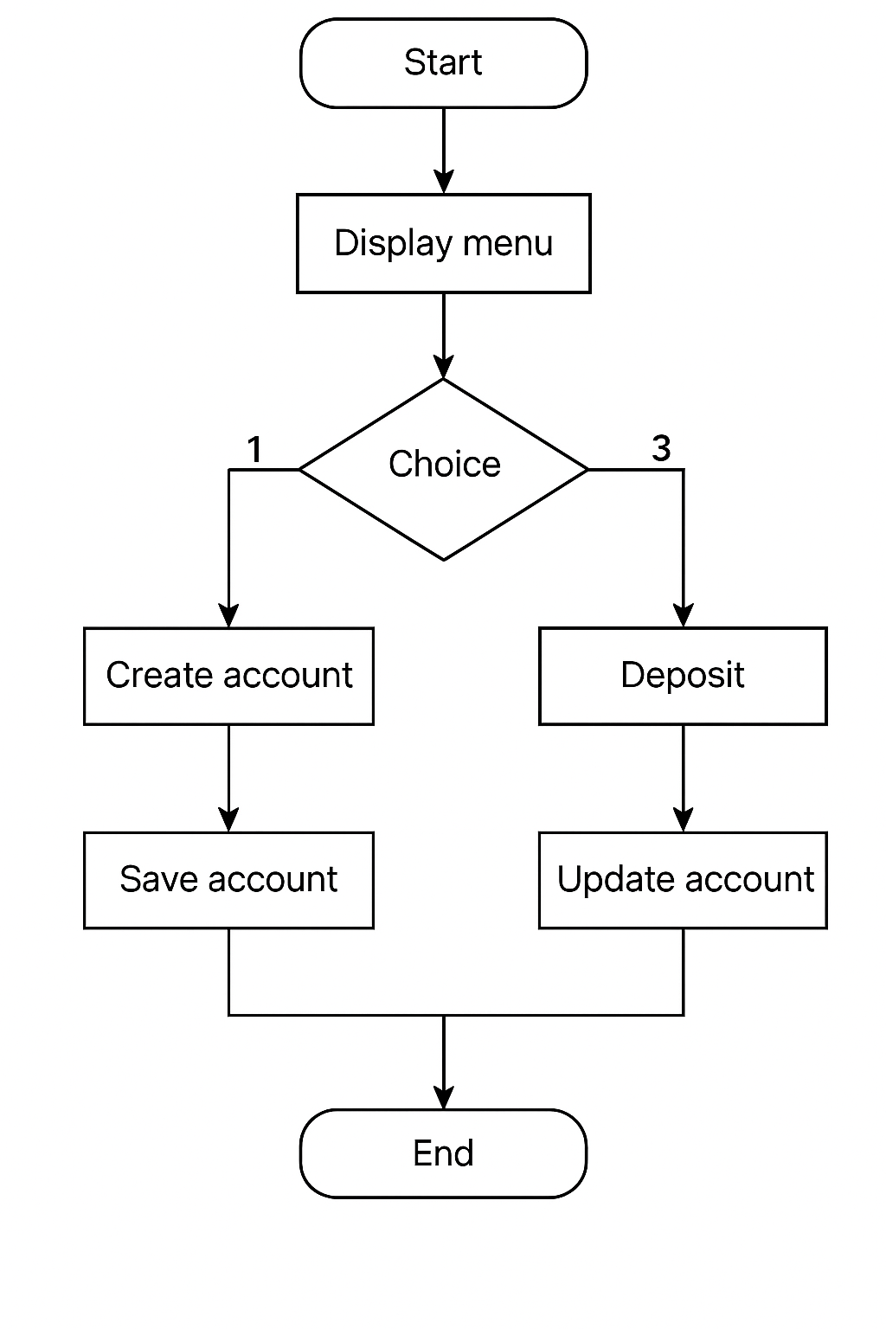DESIGN DIAGRAMS
USE CASE DIAGRAM :-
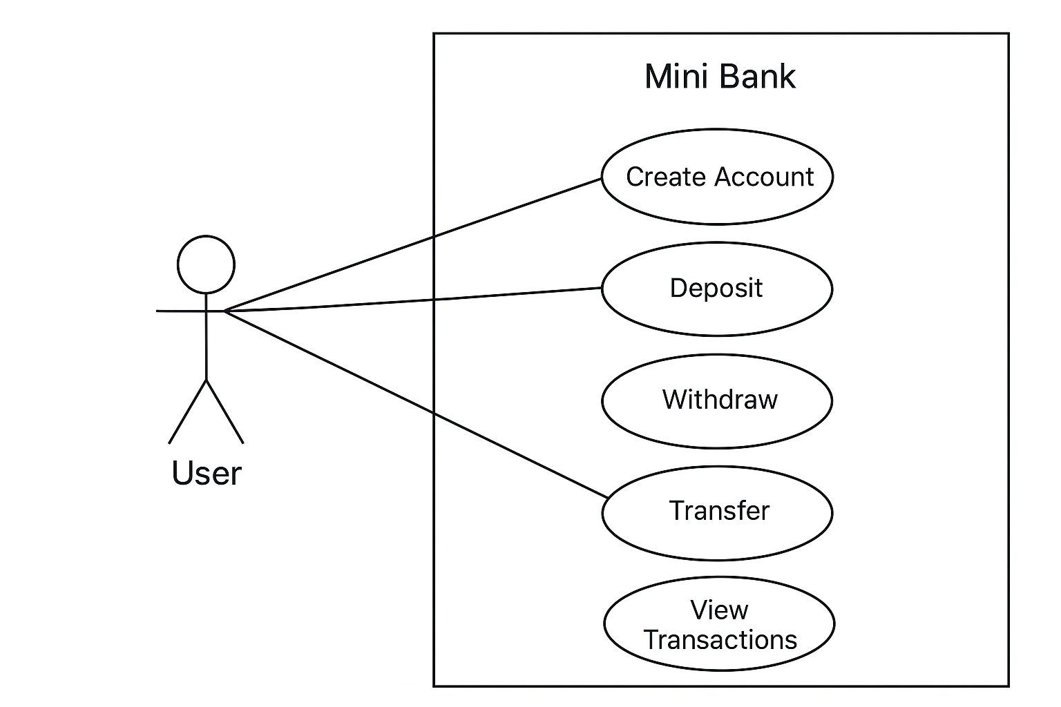

CLASS DIAGRAM :-
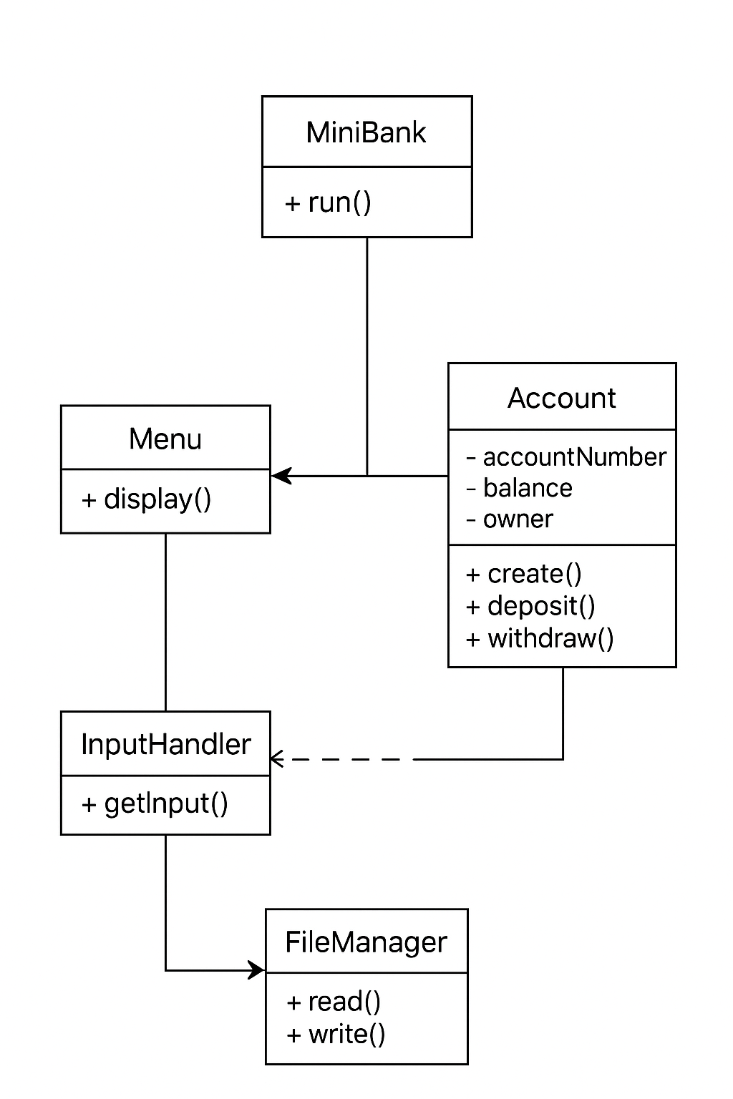
DESIGN DECISIONS AND RATIONALE
1. Modular Structure
- Code is divided into UI, logic, and data modules.
- Makes the system easier to understand, update, and debug.
2. Command-Line Interface
- Simple menu-based CLI chosen.
- Easy for beginners and matches first-year programming level.
3. JSON File Storage
- Data stored in bank_data.json.
- Provides persistence without needing a database.
4. Object-Oriented Design
- Classes used for Account and Transaction.
- Keeps data organized and models real banking entities.
5. Input Validation
- Prevents invalid operations (e.g., negative deposits).
- Ensures system accuracy and data integrity.

IMPLEMENTATION DETAILS
1. Modular Structure
- Code is divided into UI, logic, and data modules.
- Makes the system easier to understand, update, and debug.
2. Command-Line Interface
- Simple menu-based CLI chosen.
- Easy for beginners and matches first-year programming level.
3. JSON File Storage
- Data stored in bank_data.json.
- Provides persistence without needing a database.
4. Object-Oriented Design
- Classes used for Account and Transaction.
- Keeps data organized and models real banking entities.
5. Input Validation
- Prevents invalid operations (e.g., negative deposits).
- Ensures system accuracy and data integrity.
SCREENSHOTS/ RESULTS
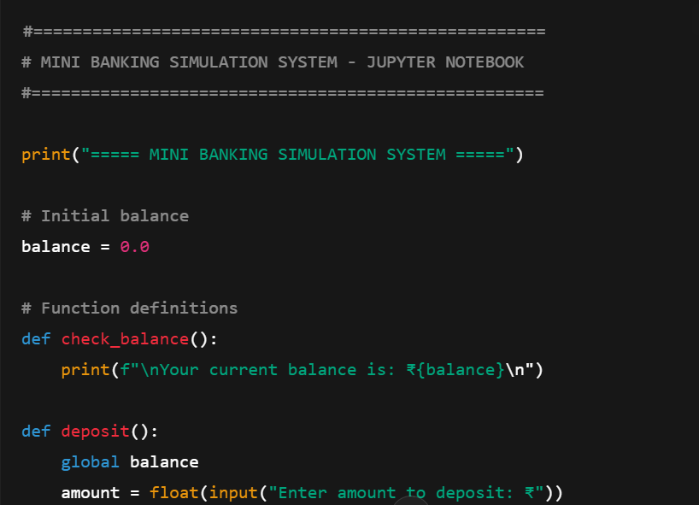
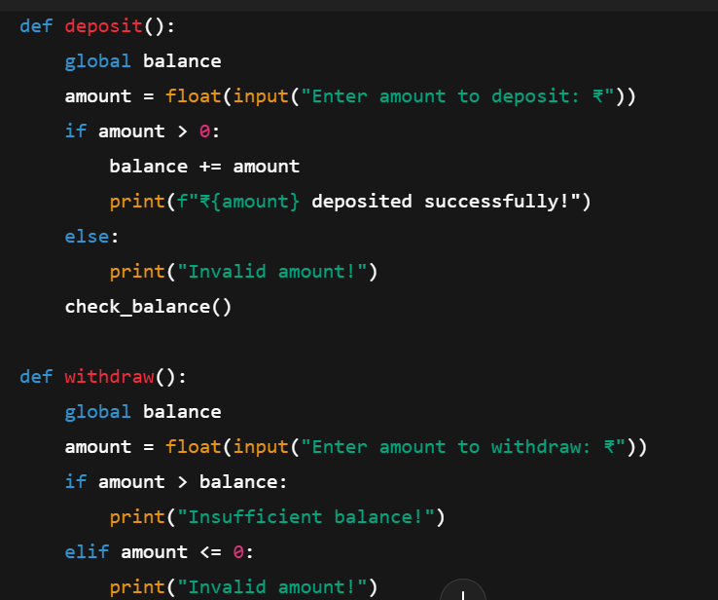
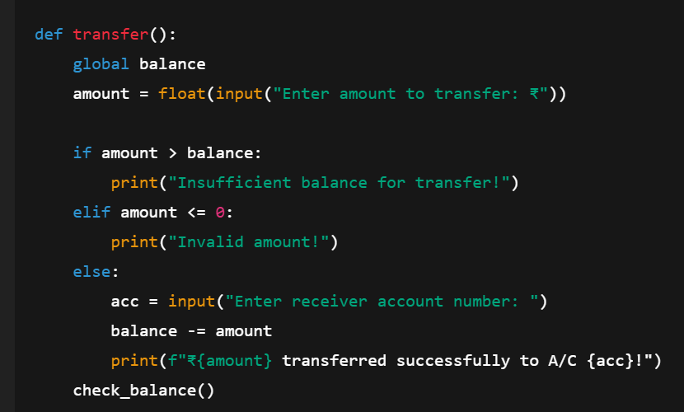
RESULTS:-
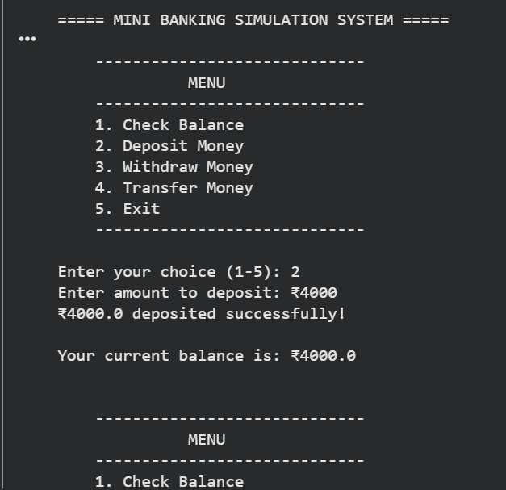
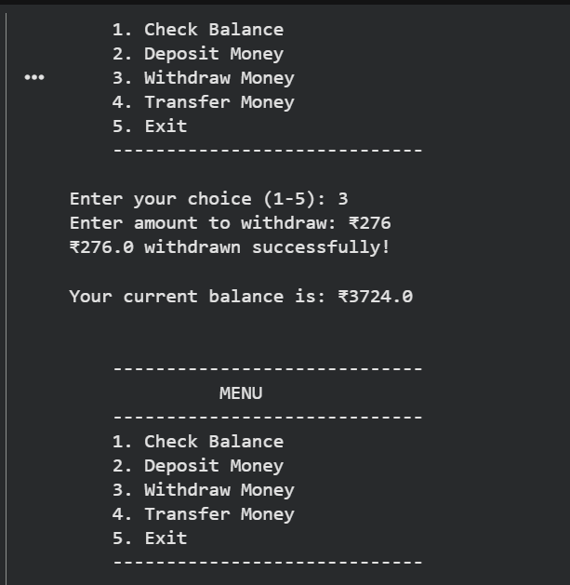
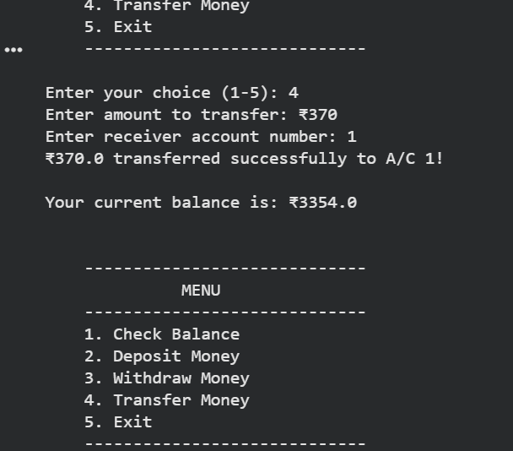

TESTING APPROACH
1. Module-wise Testing
- Each module (bank.py, cli.py, storage.py, models.py) was tested separately.
- Ensures individual components work before combining them.
2. Functional Testing
- Tested all major features:
  - Create Account
  - Deposit
  - Withdraw
  - Transfer
  - Search Account
  - View History
  - List Accounts
3. Input Validation Testing
- Checked behavior with invalid inputs:
  - Negative amounts
  - Empty names
  - Invalid account numbers
  - Non-numeric values
4. Error Handling Testing
- Verified that:
  - Withdraw does not allow overdraft
  - Transfer fails if account doesn't exist
  - System shows clear error messages
5. Data Persistence Testing
- Ensured JSON file updates correctly after each operation.
- Closed and reopened the program to verify data is saved.

CHALLENGES FACED
1. Ensuring data consistency when reading and writing to the JSON file.
2.Handling invalid user input without crashing the program.
3.Designing a clean and organized menu-based interface.
4.Managing relationships between accounts during transfers.
5.Converting Python objects into JSON-friendly formats and back.
6.Maintaining clear code separation between UI, logic, and storage layers.
7.Updating transaction history correctly for each operation.

LEARNING KEY AND TAKEAWAYS
1. Learned how to design a project using modular programming and file organization.
2.Understood how real systems use data persistence and structured storage formats.
3.Gained confidence in object-oriented programming and using classes effectively.
4.Improved skills in input validation, error handling, and building user-friendly CLI menus.
5. Learned the importance of testing and verifying each function separately.
6.Understood how to simulate real-world systems (banking) in simple code form.
7.Improved overall logical thinking, debugging, and project structuring skills.

FUTURE ENHANCEMENTS
- Add a login system with PIN/password authentication.
- Add interest calculation for savings accounts.
- Upgrade to a GUI application using Tkinter or PyQt.
- Replace JSON with SQLite database for better scalability.
- Add printable PDF statements for accounts.
- Implement admin panel for managing all accounts.
- Add support for deleting or deactivating accounts.
- Add a web-based interface using Flask or Django.

REFERENCES
- Python Official Documentation
https://docs.python.org/3/
- Real Python – File Handling in Python
https://realpython.com/read-write-files-python/
- W3Schools – Python Classes and Objects
https://www.w3schools.com/python/python_classes.asp
- GeeksforGeeks – JSON in Python
https://www.geeksforgeeks.org/json-module-python/
- Programiz – Python Object-Oriented Programming
https://www.programiz.com/python-programming/object-oriented-programming

